Another technology is possible....
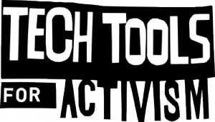
The Tech Tools for Activism collective provide help and advice about the electronic tools that our out there to help you with your activism; available in printed and online formats.

http://www.techtoolsforactivism.org


Network23 provide a free anonymous blogging platform built upon the open source Wordpress software. Whereas other sites will hand over your details to the authorities upon request, N23 is run by activist-admins who have your privacy in mind and who support freedom of expression, decentralisation of online content and the open web.

https://network23.org




Aktivix are a UK collective that provide email, mailing lists and virtual private networks; key services for your activism. Run by activists for activists, Aktivix believes in direct democracy, anti-sexism, anti-racism, anti-capitalism, self determination, local autonomy, ecology, and communal economics. They feel it is vital for communities of resistance to be able to provide for their own communication needs and not be forced to rely on insecure, profit driven means of communication plastered in advertising.

http://aktivix.org



BeTheMedia aggregate content for a wide variety of citizen journalist run sites and feeds from around the Net bringing you an extensive online gateway to what's happening on the streets around the UK. To get your finger on the pulse, head on over.
http://bethemedia.org.uk

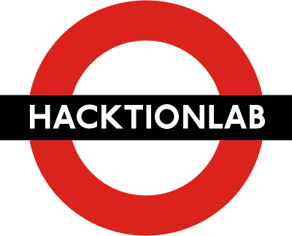
HacktionLab organises regular national events and gatherings around the UK to educate activists on tech issues and provide a forum for discussing strategy. In 2013 it will be running BarnCamp, the fifth outing of it's successful tech-meets-activism -in-a-rural-setting gathering.

http://hacktionlab.org

Get your hands on some Tech Tools to help you change the future today.

